**Deliverable 3**

**Team ThoseKoolKidz W18A**

Harsimran Saini

Arindam Mukherjee

Meilin Huang

Yulan Guo

Table of Contents

Summary of Changes: 5

High Fidelity Prototype: 7

Testing Documentation: 8

Changes to the testing documentation: 8

Abstract 8

Purpose 9

Product Description 10

Problem Statement/Test Objectives 11

Participant Profile 12

Method (Test Design) 13

Participant Greeting and Introduction 13

Orientation and Consent 13

Pre-test questionnaire 13

Usability Evaluation 15

Post-test questionnaire 15

Participant Debriefing 16

Task List 17

Test Environment/Equipment 21

Test Monitor Role 22

Evaluation Measures (data to be collected) 23

Report Contents 24

References 25

Appendix: 26

A1 Clickable Card 26

A2: Clickable Card Fixed 27

B1: Course information in study session 28

B2: Course information in study session Fixed 29

C1: Link between class and its study sessions 30

C2: Link between class and its study sessions Fixed 31

D1: Timer language 32

D2: Timer language Fixed 33

E1: My Availability 34

E2: My Availability Fixed 35

F1: Default tab 36

F2: Default tab Fixed 37

G1: Button sizes 38

G2: Button sizes Fixed 39

H1: Tabs on detail pages 40

H2: Tabs on detail pages Fixed 41

l1: Group availability in create study session 42

I2: Group availability in create study session Fixed 43

J1: Group availability in its own tab 44

J2: Group availability in its own tab Fixed 45

K1: Search vs Filter 46

K2: Search vs Filter Fixed 47

L1: Colour for status 48

L2: Colour for status Fixed 49

M1: Edit timer 50

M2: Edit timer Fixed 51

# Summary of Changes:

|  |  |  |  |  |  |  |
| --- | --- | --- | --- | --- | --- | --- |
| **#** | **Severity 0 (low) - 4 (high)** | **Principle** | **Description of issue** | **Effects on usability goals** | **Effects on user experience goals** | **Changes made** |
| 1 | 2 | Consistency and Standards (Heuristics) | Consistency and standards help users understand what they could do since they can build on knowledge they have acquired elsewhere. The standard of searchable cards, like those on the Course screen, is that they are clickable to reveal more information. Thus, users expected to be able to click the card itself rather than the join button. (Appendix A1) | Learnability | Confusing | Making the whole card clickable but leaving the join button outside for expert users. (Appendix A2) |
| 2 | 1 | Visibility (Design Principles) | Visibility refers to the visual design which provides clues about how to interact with the system. Users were asked to look for study sessions from the 'Algorithms' course in task 2, but this information was not displayed on the cards. This lacks visibility on the important aspects of the study sessions. (Appendix B1) | Effectiveness | Frustrating | Course and class information added to study session page. (Appendix B2) |
| 3 | 2 | Structure (Design Principles) | Design should organize the user interface purposefully, in meaningful and useful ways by putting related elements together and by eliminating unrelated things.  Study sessions for specific courses were expected to be displayed/linked to their courses/classes. Not having these in the relevant sections can confuse the user. (Appendix C1) | Learnability and Effectiveness | Disorientating | Added a button to create a link between classes and their study session – more flexibility for user. (Appendix C2) |
| 4 | 2 | Match between system and the real world (Heuristics) | Match between system and the real world refers to ensuring the system uses familiar concepts to the target audience and "speaks the user's language".  The word 'Pomodoro' for the timer is unfamiliar for the user and should not be used. (Appendix D1) | Learnability | Confusing | Remove the ‘Pomodoro’ tab and make it as a function to start the timer for the specific task. (Appendix D2) |
| 5 | 3 | Structure (Design Principles) | Users were not able to find the 'My availabilities' section and expected it to be its own tab. (Appendix E1) | Learnability | Disorientating | Created a new bottom tab for availabilities. (Appendix E2) |
| 6 | 1 | Consistency and Standards (Heuristic) | User found it was confusing that the initial tab opened is at the right-hand side on the default home page, which is inconsistent with other similar applications. (Appendix F1) | Learnability | Disorientating | Changed the order of the sub tabs. (Appendix F2) |
| 7 | 4 | Structure (Design Principles) | Users found the next button inconveniently positioned. This in turn creates poor usability because of users struggling to click on next to progress through the form. As such, this led to user frustration due to having them spend more time clicking the button, when that time could have been used elsewhere more efficiently. (Appendix G1) | Efficiency and learnability | Frustrating | Stretching out the next button to give users more room to click (Appendix G2) |
| 8 | 3 | Consistency and standards (heuristics principles) | Users found that when opening more details for a clicked page, they would always have the navigation bar at the bottom. As a result of not staying consistent to the conventional mobile standards, this creates a negative experience for users as they preferred having that extra screen real estate to display more of the form. As such, this increased the number of scrolls as well. (Appendix H1) | Efficiency, Learnability | Annoying, frustrating | Removing the navigation bar when users click on something with a lot of detail, as well as adding a back button to ensure user freedom (Appendix H2) |
| 9 | 4 | Structure (Design Principles) | Users were not able to find the 'Group availabilities' section and expected it to be in the create new study session form itself. (Appendix I1) | Efficiency | Confusing | Added group availabilities as part of the create form. (Appendix I2) |
| 10 | 4 | User control and freedom (Heuristics) | User control and freedom refers to ensuring users are able to feel in control of an action and actions are not unpredictable. Users would like to see Group Availabilities outside of creating a new study session. Forcing the user to go through creating a study session to see the availability impedes on their user control and freedom. (Appendix J1) | Utility | Annoying | Created a separate section for availabilities. (Appendix J2) |
| 11 |  | User control and freedom + consistency and standards  (Heuristics) | Users found themselves confused when they tried to make a filter search query but had both the search bar and the filter search form displayed. As a result of presenting them with multiple options, this prevents users from feeling like they are in control of their actions due to the cognitive overload that arises. As such, by adhering to industry standards, users could focus their attention span on one item at a time. (Appendix K1) | Efficiency, Effectiveness, Learnability | Frustrating, annoying, confusing | Removed the search bar when users click on the filter button. This way we don’t overload them with unnecessary information. (Appendix K2) |
| 12 | 4 | Flexibility and efficiency of use (Heuristics) | Flexibility and efficiency of use refers to providing alternative ways/paths through an application that can cater for different users.  Users that are colourblind would have a difficult time using colour to distinguish whether a time slot is available. (Appendix L1) | Utility | Unusable | Added other cues to display information other than just colour. (Appendix L2) |
| 13 | 1 | User control and freedom + consistency and standards | Users expected an edit button and did not realise clicking the numbers would allow you to edit the timer. (Appendix M1) | Learnability | Frustrating | Added new screen for them to start, pause and edit the timer however they like. (Appendix M2) |

# High Fidelity Prototype:

Link to our high fidelity prototype: <https://www.figma.com/file/AwkJV4SCviMZyCVtwm851o/Deliverable-3---Figma-Prototype?type=design&node-id=0%3A1&mode=design&t=PJPZ5kyoLu9SKHih-1>

# Testing Documentation:

Please find testing documentation below.

## Changes to the testing documentation:

Changes were made to the tasks section of the usability testing documentation due to the following 4 reasons:

1. Through our usability testing we found that the wording on some of the usability tasks was confusing. This included adding the course number in task 2, and rewording tasks 3 –5
2. Made sure to split task 5 into new steps as it was content heavy
3. Features and screens were added/changed due to the usability feedback and the tasks needed to reflect these changes to effectively test the application.
4. Reworded some of the post questions as they sounded very similar

# Abstract

This document involves the procedures and processes to run a usability test for the study session application created in the COMP4511 Group Project by Team ThoseKoolKidz. The aim of this application is to allow university students to establish mutual study accountability for motivation, easily find suitable study partners, optimise study resources amongst themselves, and feel that they are part of a learning community.

# Purpose

The primary purpose of this usability test is to evaluate the usability of the Study Session application. We will therefore ensure that the aims of this application are tested. The aim of the application is to allow university students to establish mutual study accountability for motivation, easily find suitable study partners, optimise study resources amongst themselves, and feel that they are part of a learning community. Through this test, we intend to identify any usability issues that may hinder the application’s ability to meet its aims and gather user feedback and insight to refine it, provide a seamless and effective platform for university students to collaborate, motivate and learn together.

# Product Description

This is a study session collaboration application for university students that mainly focuses on face-to-face interactions, which offers services allowing users to seamlessly browse, search and join the courses that are tailored to their academics, find the suitable study partners and participate in face-to-face study sessions. With a focus on enhancing the face-to-face interaction, our study session collaboration application is the ideal tool for university students looking to enrich their learning through in-person collaboration and mutual support.

From market research we found that a face-to-face focus is missing from the market, and on further investigation, via questionnaires, users also were looking for a comprehensive application that comprises of all the user journey stages of the face-to-face study session process. This includes communication with peers, booking a location and participating in the sessions.

The product is still in the early stages of development and the version that will be tested is a low-fidelity prototype.

# Problem Statement/Test Objectives

University students find it difficult to organise and partake in study sessions. The most common issues that they face are finding suitable face-to-face study partners and coordinating study sessions efficiently. The goals of these students are to establish mutual study accountability for motivation, easily find suitable study partners, optimise study resources amongst themselves, and feel that they are part of a learning community.

# Participant Profile

We are expecting to test a total of 12 users, split into two groups. These users will be split roughly into expert/novice characteristics of experience with study applications. Participants will be selected randomly, and their novice/expert status will be determined from a pre-test questionnaire.

The characteristics of the groups are shown below:

|  |  |  |
| --- | --- | --- |
| **Characteristics** | **Range** | **Frequency Distribution** |
| Prior experience with study applications | None to 3 months | 75% of users are expected to be in this group (from questionnaire statistics) |
| Familiar with study applications | Once a day – once a week | 25% of users are expected to be in this group (from questionnaire statistics) |

# Method (Test Design)

## Participant Greeting and Introduction

Each participant will be personally greeted by the test facilitator and made to feel comfortable and relaxed.

## Orientation and Consent

Participants will each receive a scripted, verbal introduction and orientation, which will explain the purpose and goals of the test. They will also be assured that the application is what is being tested, not themselves. Participants will then be introduced to the equipment and told that their voices and the screen sharing the application will be recorded, and these will be used for later review, and will not be exposed these to others. Two copies of a consent form will be given to each participant to sign, where the participant is free to keep one copy of this form, and the second copy will be filed away by the evaluation team. The participant is free to leave the test at any time or choose not to participate after reading the consent form.

## Pre-test questionnaire

Before the usability evaluation session, each participant will be asked to complete a pre-test questionnaire. This questionnaire will be used to establish the participant’s level of expertise.

**Pre-test Questionnaire**

**Note:** For scale question, 1 means extremely poor and 5 means extremely well.

1. What age group are you in?

A. Under 25

B. 25-30

C. 31-40

2. What is your current study level?

3. Have you ever used an app dedicated to studying before?

A. Never

B. Have used one before in the past

C. Have used multiple in the past

D. Currently using one

E. Currently using more than one

3a. If so which ones?

4. Have you ever used an app dedicated to organising study sessions before?

A. Never

B. Have used one before in the past

C. Have used multiple in the past

D. Currently using one

E. Currently using more than one

4a. If so which ones?

5. What device(s) do you usually use for study apps?

6. From a scale of 1-5, how would you rate your confidence in using mobile phones?

7. From a scale of 1-5, how would you rate your confidence in navigating through a study app on your mobile phone?

## Usability Evaluation

The usability evaluation session consists of a series of tasks that the participants will carry out while being observed. These tasks will be conducted in the following manner:

1. A script will be read out loud to the participant by the test monitor (facilitator), detailing the task to be accomplished. The participant will then be asked to attempt the task.

During the usability evaluation, the observer will make notes on the participants interaction with the test artefact. Any errors or issues that the participant encounters will be noted. Where applicable the facilitator will encourage the participant to verbalise his/her thoughts and ask relevant questions. The observer will also make note of any unusual circumstances that may not be picked up by the recording devices.

## Post-test questionnaire

After the usability evaluation session, each participant will be asked to complete a post-test questionnaire. This questionnaire will be used to gather the final thoughts of the participant on the user interface.

**Post-test questionnaire**

**Note:** For scale question, 1 means extremely poor and 5 means extremely good.

1. From a scale of 1-5, how user-friendly is the interface?

2. From a scale of 1-5, how would you rate your overall experience with our interface?

3. What are the best and worst things about our interface?

4. Is there anything about our interface that you would change or add to improve its usability?

## Participant Debriefing

Each participant will be debriefed by the test monitor. The topics of the questions will be:

1. Overall satisfaction with the application
2. Any comments

# Task List

The following five tasks will be used during the usability evaluation session:

|  |  |
| --- | --- |
| Task 1 | Description |
| Task | The user wants to view a list of courses on the study app. They then want to join the COMP3511 TH16A class. |
| Starting State | Log In screen |
| Successful Completion Criteria | 1. Navigate to sign in screen 2. Create account 3. Log in and go to course page 4. Make a search query to find the class by name or manually find it 5. Click the big green join button |
| Benchmark | 2 mins |
| Script (Task Scenario) | Hello [USER], welcome to task 1. You are a new student looking to create an account and view the list of courses on the study application. After that you will need to join the TH16A class.   Remember that this is not a test, and we are not assessing your abilities but testing the usability of our prototype, so please take your time and complete the task to the best of your ability. |

|  |  |
| --- | --- |
| Task 2 | Description |
| Task | Find the list of users that are attending the study session for the T16A “Algorithms” class. |
| Starting State | Courses home page |
| Successful Completion Criteria | 1. Navigate to the study sessions tab 2. Click the filter section next to the search bar 3. Enter in “Algorithms” next to class and hit search 4. Click on the study session e.g., CS st00dents 5. Navigate to the “List of Users” section |
| Benchmark | 1:30 mins – 2 mins |
| Script (Task Scenario) | Hello [USER], welcome to task 2. You now want to view the users in a study session for the T16A “Algorithms” class.   Remember that this is not a test, and we are not assessing your abilities but testing the usability of our prototype, so please take your time and complete the task to the best of your ability. |

|  |  |
| --- | --- |
| Task 3 | Description |
| Task | The user wants to add a new task to the to-do list and would like to complete it in 5 hours. After doing so, they want to start a timer for this specific task. |
| Starting State | Study Tools home page |
| Successful Completion Criteria | 1. Navigate to the “Study Tools” section in the navigation bar 2. Click the plus icon at the bottom-right of the home page to create a new task 3. Enter in your task name, select Tag, Due date and drag to set a 5-hour completion time, then press "✓” icon to add the new task. 4. Now click on the “▷” icon on the right-hand side of the new created task to start a 5-hour timer |
| Benchmark | 2:00 mins – 2:30 mins |
| Script (Task Scenario) | Hello [USER], welcome to task 3. Now you find yourself busy with a new task called “Lab 1”, and you want to finish it within 5 hours. Once you've added this task to your to-do list, proceed to initiate a timer dedicated to this specific task to help you stay on track and ensure its timely completion!  Remember that this is not a test, and we are not assessing your abilities but testing the usability of our prototype, so please take your time and complete the task to the best of your ability. |

|  |  |
| --- | --- |
| Task 4 | Description |
| Task | The user wants to view their availabilities on 14/12/2023. |
| Starting State | Study Sessions homepage |
| Successful Completion Criteria | 1. User selects the ‘Availabilities’ tab on the navigation bar. 2. User checks their availabilities |
| Benchmark | 1 min and only 1 click |
| Script (Task Scenario) | Hello [USER], welcome to task 4. You now want to see your own availabilities on the 14th of December 2023.  Remember that this is not a test, and we are not assessing your abilities but testing the usability of our prototype, so please take your time and complete the task to the best of your ability. |

|  |  |
| --- | --- |
| Task 5 | Description |
| Task | The user wants to create study sessions on 12/12/2023 and invites friends after checking the best time for the others to meet up. |
| Starting State | Study Sessions homepage |
| Successful Completion Criteria | * 1. User selects the Study Sessions tab on the navigation bar   2. User clicks on the “+” button at the bottom right corner to create new study session.   3. Add participants   4. User chooses the date on 14/12/2023.   5. Select the appropriate time   6. Move to location step   7. Optionally add a room   8. Create session |
| Benchmark | 1:30 mins – 2:00 mins |
| Script (Task Scenario) | Hello [USER], welcome to task 5. You now want to create a new study session on the 14th of December 2023. Invite some friends and study partners into the session as well.  Remember that this is not a test, and we are not assessing your abilities but testing the usability of our prototype, so please take your time and complete the task to the best of your ability. |

|  |  |
| --- | --- |
| Task 6 | Description |
| Task | View the group availabilities for the “Comp3511” course, “Comp4511” course and yourself. |
| Starting State | Study Sessions homepage |
| Successful Completion Criteria | 1. Select availabilities section in the nav bar 2. Click on the “Group availabilities” section on the top tab 3. Select the groups 4. Check their availabilities |
| Benchmark | 30 – 45 seconds |
| Script (Task Scenario) | Hello [USER], welcome to task 6. You now want to check the group availabilities for the “Comp3511” course, “Comp4511” course and yourself.  Remember that this is not a test, and we are not assessing your abilities but testing the usability of our prototype, so please take your time and complete the task to the best of your ability. |

|  |  |
| --- | --- |
| Task 7 | Description |
| Task | Adjust the font size of the application |
| Starting State | Study Sessions homepage |
| Successful Completion Criteria | 1. Select the settings page 2. Click on accessibility settings 3. Use the slider to adjust the font size |
| Benchmark | 20 - 35 seconds |
| Script (Task Scenario) | Hello [USER], welcome to task 7. You find yourself struggling to make out the content on the screen and you want to increase the font size to improve readability.  Remember that this is not a test, and we are not assessing your abilities but testing the usability of our prototype, so please take your time and complete the task to the best of your ability. |

# Test Environment/Equipment

All usability evaluation sessions will be conducted over Teams using the researchers’ laptops and screen sharing features.

The following equipment will be used across the range of participants:

1. MS Teams: To communicate with the participant and share screen for the tests. The shared computer screen will be recorded to ensure that the interaction between participant and the prototype is available for later review.
2. Microphones: these will be used to record participants and the think-aloud protocol data, which can later be reviewed, and transcripts created to ensure that all information is available for the analysis stage.
3. Computer with an internet connection: the participant will be interacting with the prototype as part of the usability evaluation testing.

# Test Monitor Role

The test monitor will be present in the Teams call with each participant while conducting the test, and act as a facilitator of the evaluation. An observer will also be present on the call, making observations based on the participant’s commentary and other behavioural aspects such as facial expressions and gestures.

The test monitor will not lead the participant to the answer or the correct series of steps and will not volunteer help unless the participant is in serious risk of not completing the task successfully. A basic time frame for offering any serious help is approximately 5 minutes. The test monitor will only respond to questions that enquire what to do and how to do if their answer will not threaten to skew the test results.

The test monitor will be on hand in case of equipment failure or other problems.

The test monitor will participate in active listening and encourage an easy-going atmosphere throughout the evaluation session.

# Evaluation Measures (data to be collected)

The following evaluation data will be collected and later analysed:

|  |  |
| --- | --- |
| Performance Measures | Behavioural Measures |
| Number and percentage of tasks completed correctly with and without assistance | Participant comments |
| Number of errors encountered during each of the tasks | Participant perception of site |
| Number of errors encountered during the whole of the evaluation | User satisfaction |
| Number of times participant asked for help | Initial reaction when attempting each task |
| Negative comments count | Relevant quotes |
| Positive comments count | Relevant quotes |
| Count of incorrect icon selection | Participant perception of site |
| An interview at the end of the usability test | Participant interview responses |
| Number of screen presses to complete a task and the time it took to complete the task | Participant perception of site |

# Report Contents

A formal report will be produced summarising all the results and refining the application design. All the information making up this report will be kept internally for research and educational purposes.

# References

Sasha, V. & Simon, P. (2008). *Usability Test Plan Template Version 1.2* [PDF file]*.* Retrieved from<https://moodle.telt.unsw.edu.au/pluginfile.php/10679265/mod_resource/content/1/HCI_2008_Usability_Test_Plan_Sample.pdf>

# Appendix:

## A1 Clickable Card

## A2: Clickable Card Fixed

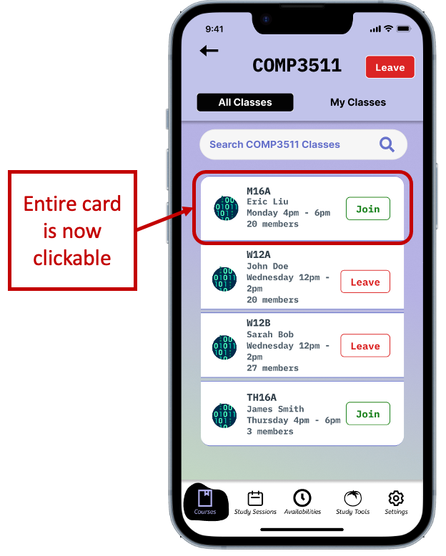

## B1: Course information in study session

## B2: Course information in study session Fixed

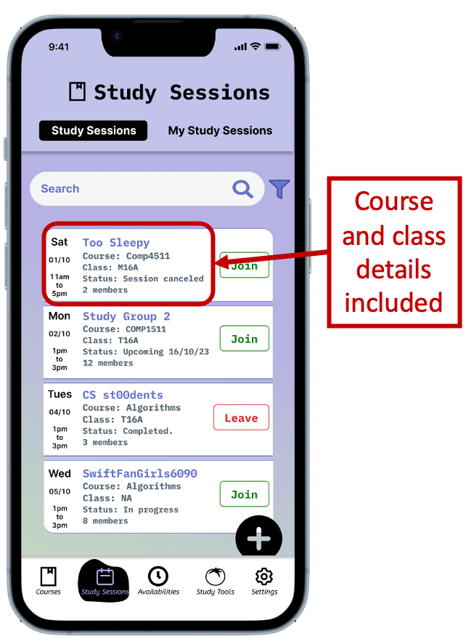

## C1: Link between class and its study sessions

## C2: Link between class and its study sessions Fixed

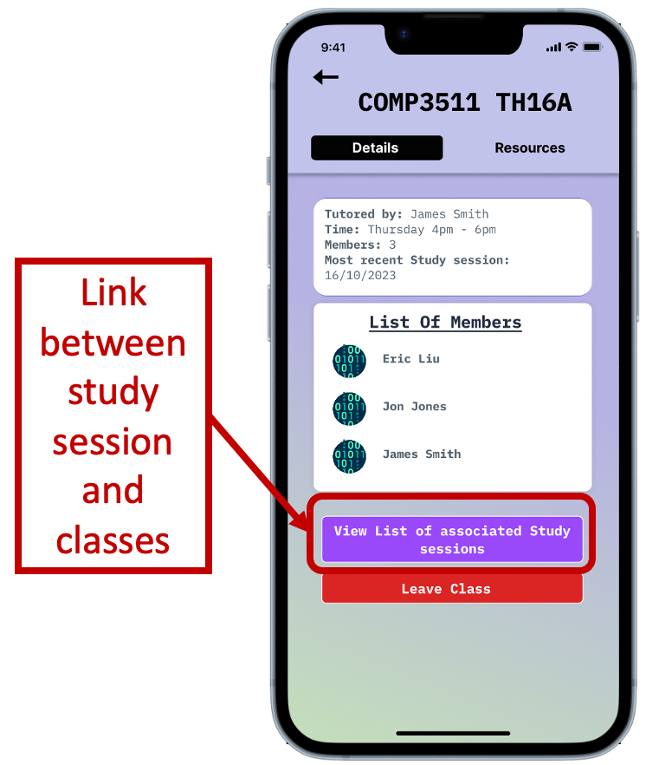

## D1: Timer language

## D2: Timer language Fixed

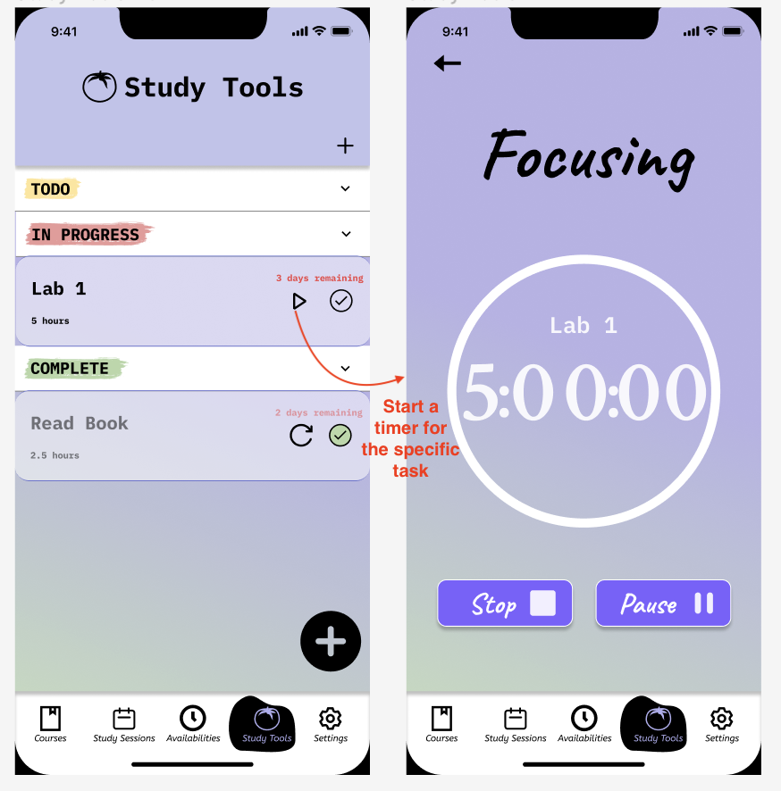

## E1: My Availability

## E2: My Availability Fixed

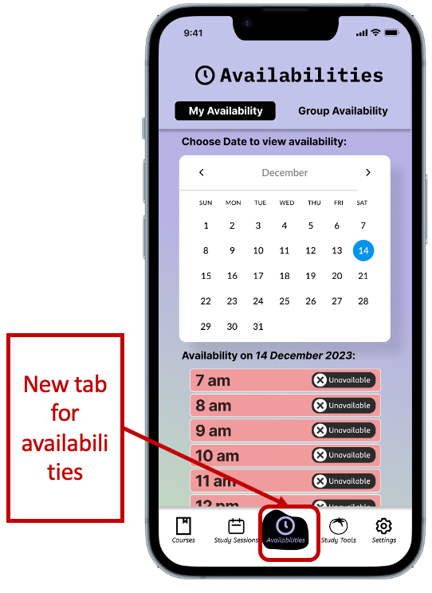

## F1: Default tab

## F2: Default tab Fixed

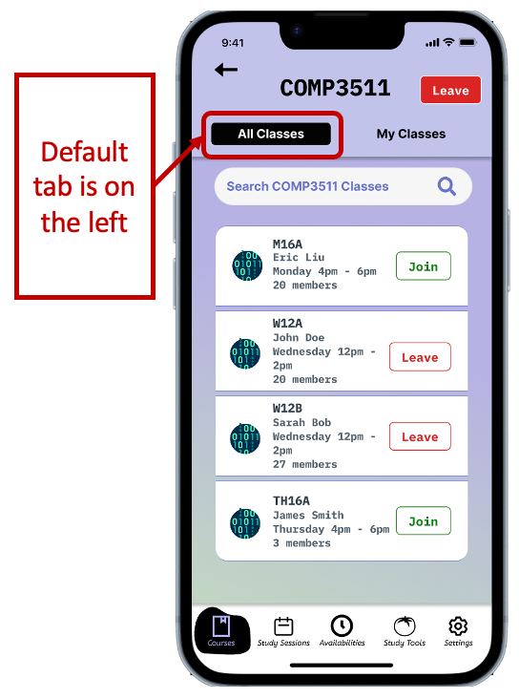

## G1: Button sizes

## G2: Button sizes Fixed

## H1: Tabs on detail pages

## H2: Tabs on detail pages Fixed

## l1: Group availability in create study session

## I2: Group availability in create study session Fixed

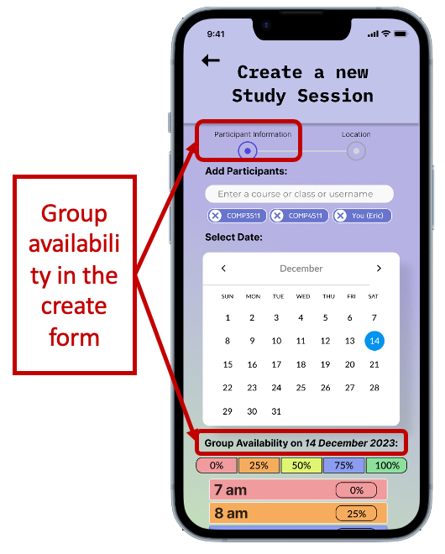

## J1: Group availability in its own tab

## J2: Group availability in its own tab Fixed

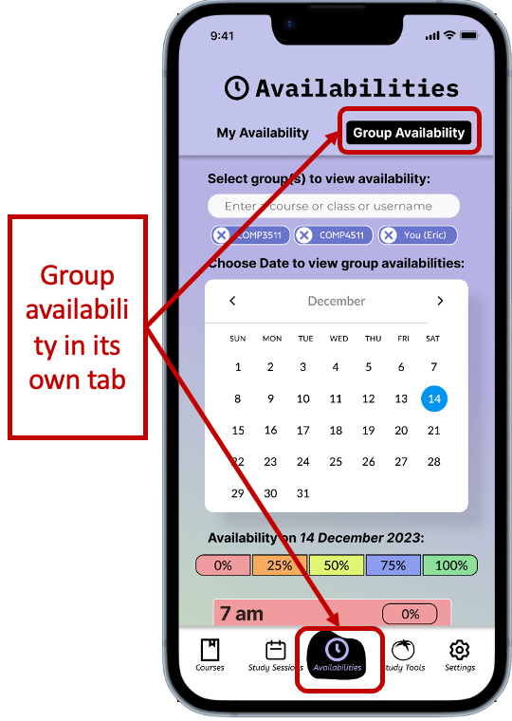

## K1: Search vs Filter

## K2: Search vs Filter Fixed

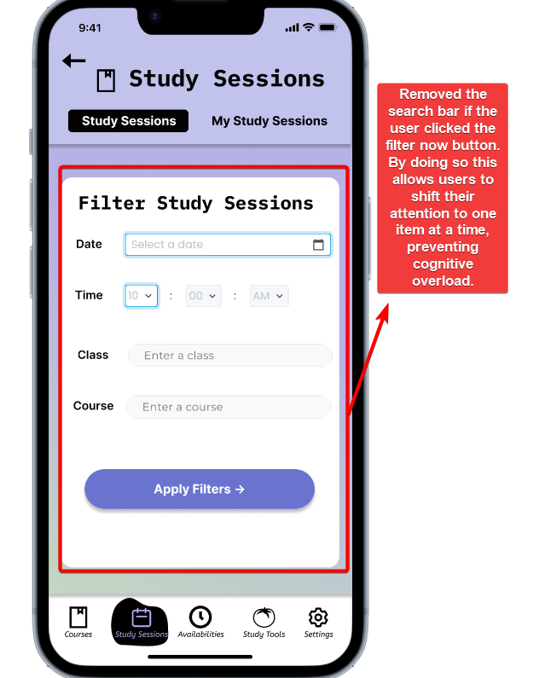

## L1: Colour for status

## L2: Colour for status Fixed

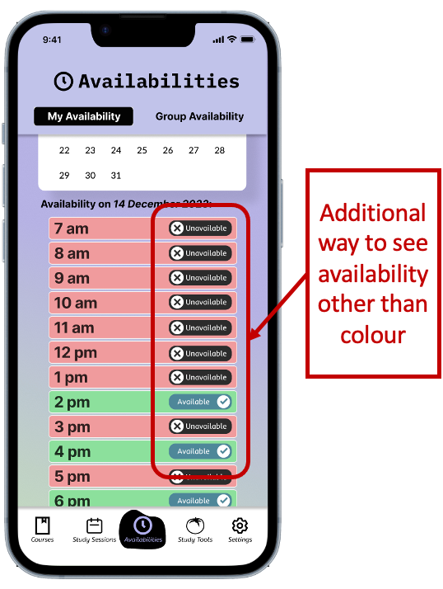

## M1: Edit timer

## M2: Edit timer Fixed

